CUDA Naive FP32 GEMM — Version 1 Benchmark Report
GPU: CUDA-capable device | Kernel: gemm_gpu_basic_f32.cu | Format: FP32 | Compiler: nvcc -O3 -DALIGN -DRESTRICT

1. Executive Summary
This report presents benchmark results for version1_naive_f32, the first CUDA implementation in this project. The kernel uses a naive global-memory approach where each thread computes one element of the output matrix C. Four thread block configurations were evaluated: 16×16, 32×8, 32×16, and 32×32 across six matrix sizes (N = 6,144 to 16,400).
Key findings: The 32×32 configuration achieves best throughput for N ≤ 12,288 (peak 641 GFLOPS at N=8,192), while 32×16 is superior for N ≥ 15,000. The 32×8 configuration collapses dramatically at N=15,000, losing approximately 63% of its N=12,288 throughput. Compared to the best sequential CPU baseline (icx -O3 -xHost, FP64), speedups range from 14.5× to 30.3×.
Important caveat: This kernel operates in FP32 (single-precision) while all CPU baselines used FP64 (double-precision). The observed speedup partially reflects the precision difference, not only architectural differences.

2. Kernel Architecture
The kernel sgemm_plain_global_kernel assigns each CUDA thread a unique (row, col) position in the output matrix C. Thread global coordinates: gx = blockIdx.x × TILE_W + threadIdx.x (column) and gy = blockIdx.y × TILE_H + threadIdx.y (row). Each thread independently computes the complete dot product of row gy of A with column gx of B, accumulating in a local register. A boundary check handles non-divisible matrix sizes.
Memory access pattern: Reads of B[k×N+gx] are coalesced across the warp. Reads of A[gy×N+k] are non-coalesced since threads in a warp differ in gy. This asymmetry limits memory bandwidth utilization and is the defining characteristic of this naive implementation. No shared memory is used.

3. Timing Methodology
GPU timing uses CUDA events: cudaEventRecord before and after the kernel launch. cudaDeviceSynchronize is called before the start event. cudaEventSynchronize is called after the stop event to ensure kernel completion. This provides millisecond-precision timing, excluding host-device memory transfer time.

4. Results

4.1 Best GFLOPS per Matrix Size
Performance peaks at N=8,192 with 641 GFLOPS (32×32 tile), then decreases for larger N, reaching 418 GFLOPS at N=15,000 before recovering to 441 GFLOPS at N=16,400 with 32×16 tile. The transition from 32×32 to 32×16 as best tile reflects a change in GPU occupancy and memory bandwidth balance at larger problem sizes.
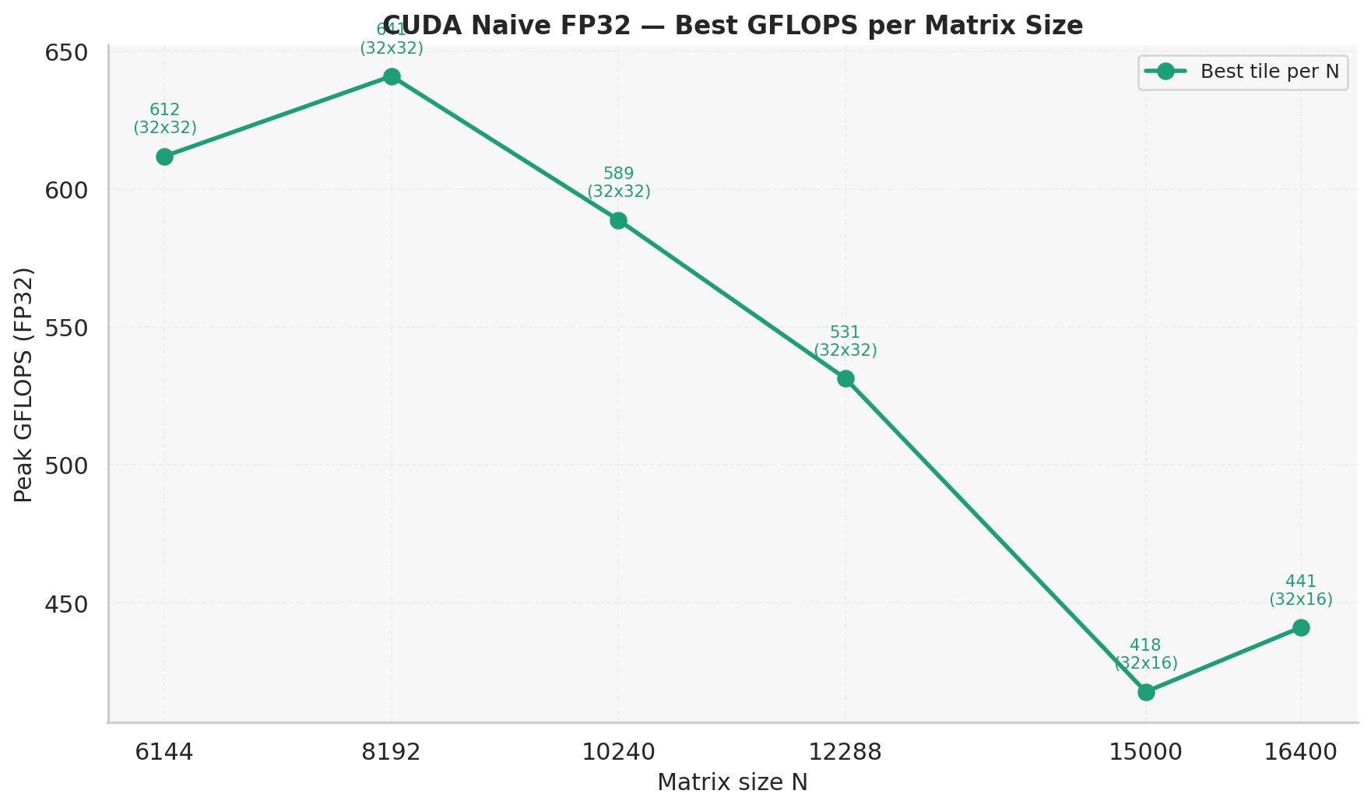
Figure 1. Best GFLOPS per matrix size. Best tile configuration selected per N; tile label shown at each point.

4.2 Best Runtime per Matrix Size
Runtime grows approximately as N³, consistent with O(N³) complexity. Best runtime at N=6,144 is 0.758 s (32×32). At N=16,400 the best runtime is 20.001 s (32×16).
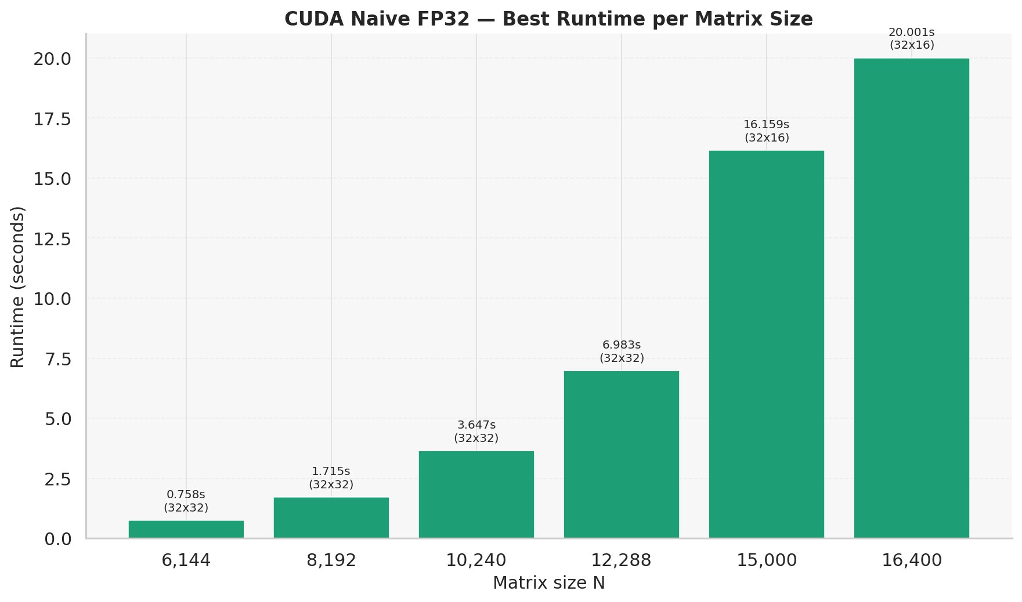
Figure 2. Best kernel runtime per matrix size (FP32, best tile per N).

4.3 GFLOPS for All Tile Configurations
The 32×32 tile leads for N ≤ 12,288. The 32×16 tile overtakes at N ≥ 15,000. The 16×16 tile consistently underperforms (256 threads vs 1024 for 32×32). The 32×8 configuration collapses at N=15,000 dropping from 462 to 156 GFLOPS — a 66% loss — before partially recovering to 199 GFLOPS at N=16,400. This behavior likely reflects register pressure or warp scheduling at that specific problem size.
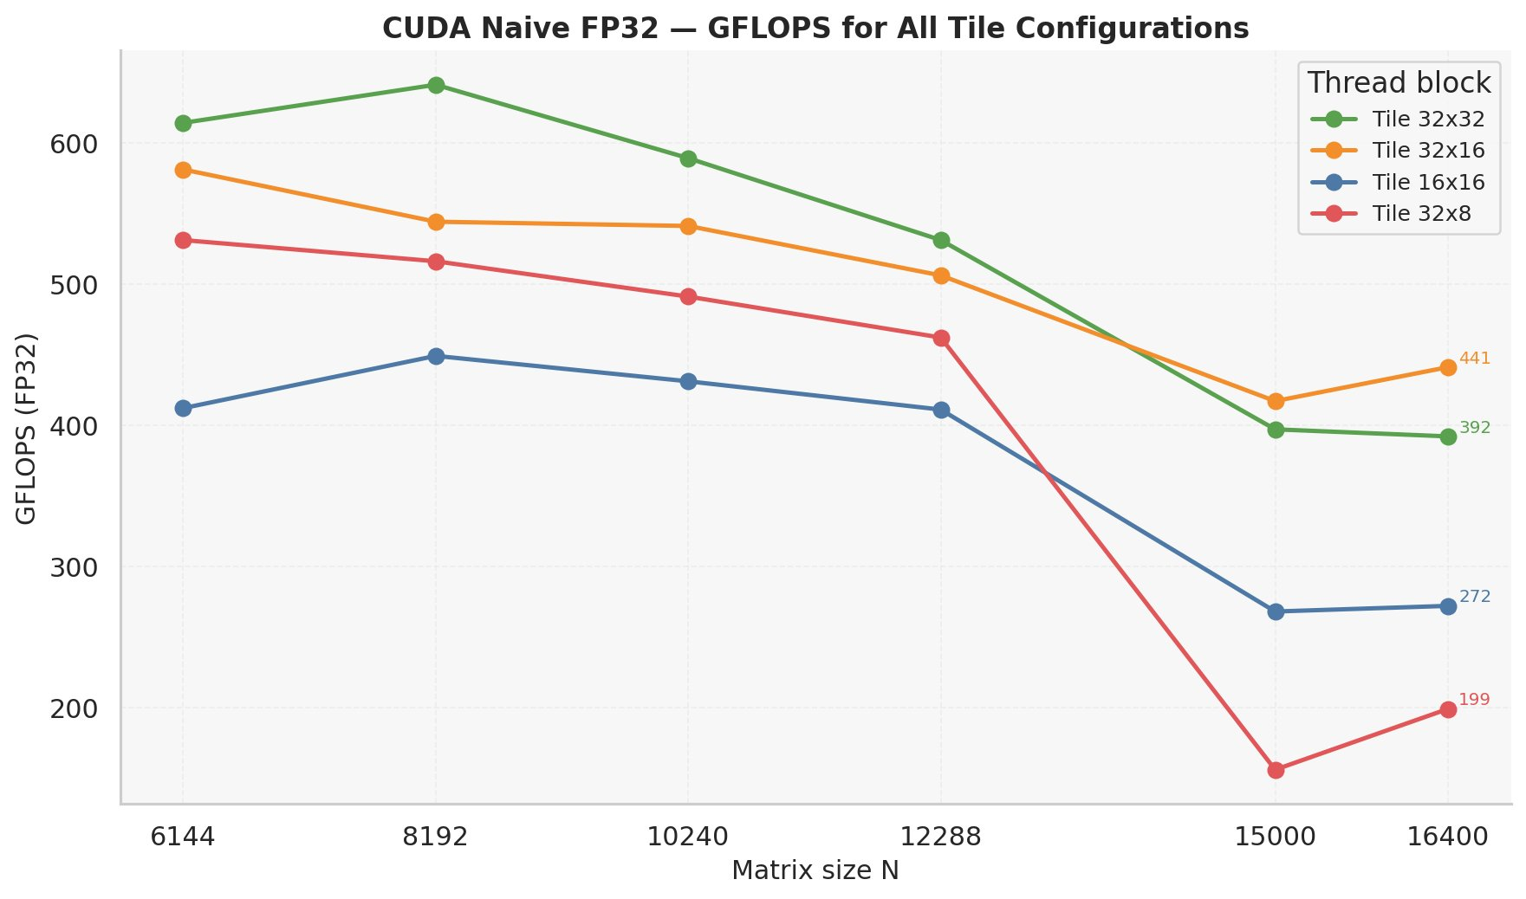
Figure 3. GFLOPS for all four tile configurations across all matrix sizes.

4.4 Runtime for All Tile Configurations
At N=15,000 the 32×8 tile runtime jumps to 43 seconds — more than 2.5× the next-worst configuration. The 32×32 and 32×16 tiles show smooth, well-behaved runtime growth throughout.
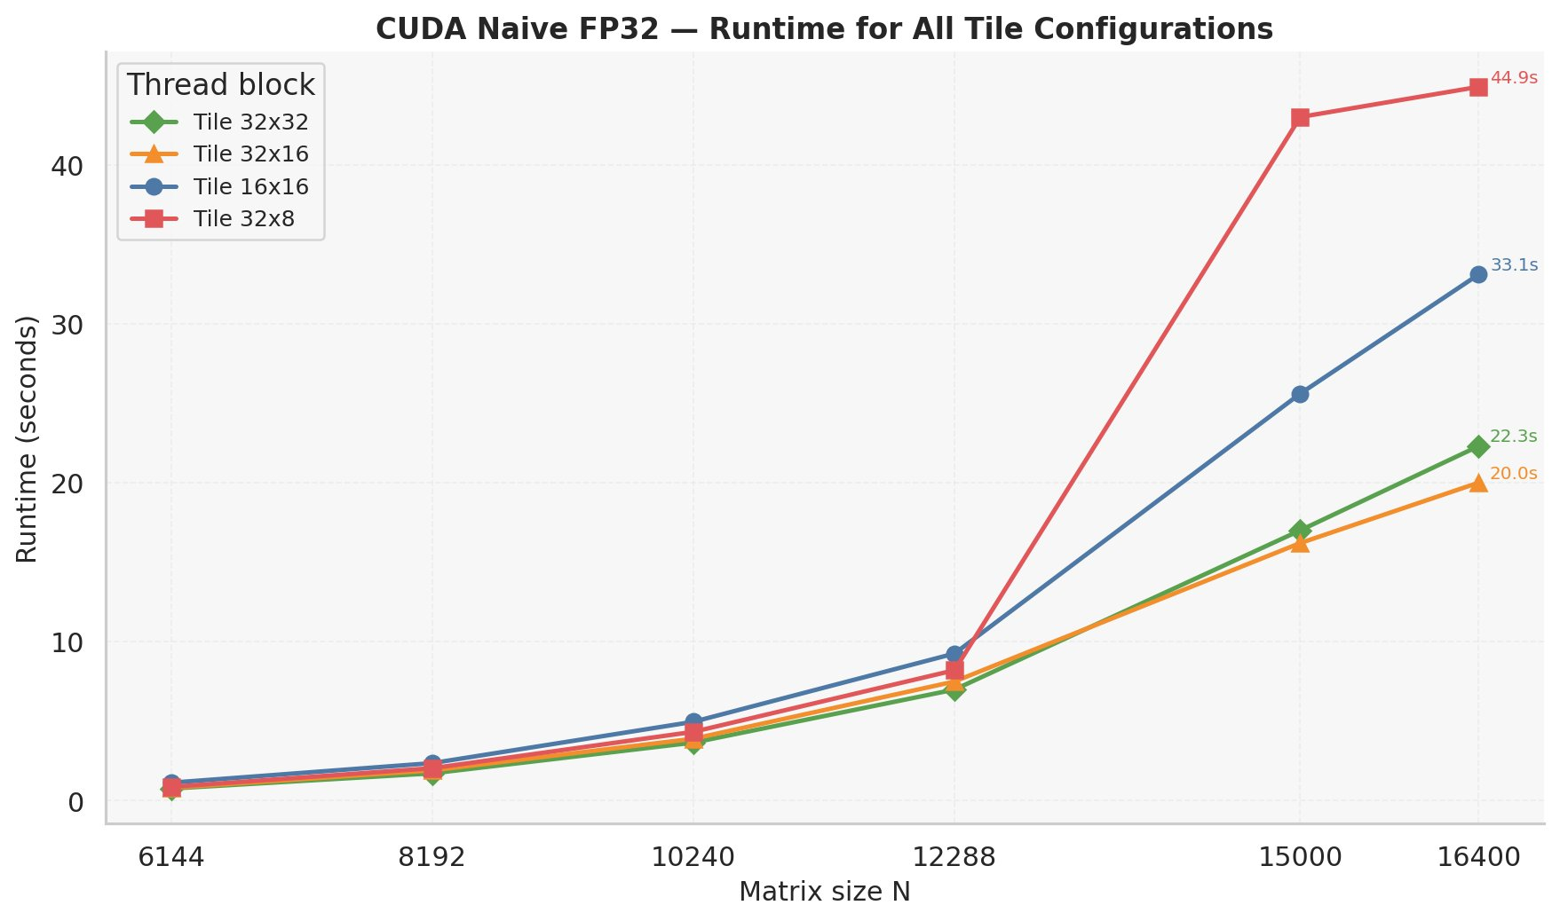
Figure 4. Runtime for all four tile configurations. Note the sharp 32×8 spike at N=15,000.

4.5 Tile Configuration Ranking at N=8,192
At the peak performance point (N=8,192): 32×32 achieves 641 GFLOPS, followed by 32×16 (544), 32×8 (516), and 16×16 (449). The ranking is consistent with the general trend for smaller N values.
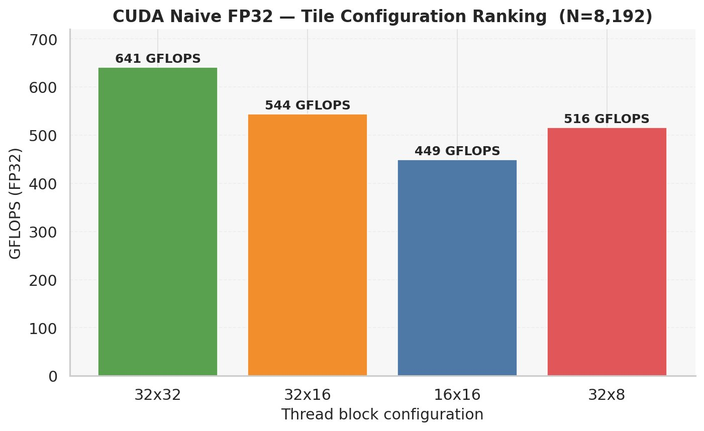
Figure 5. Tile configuration ranking at N=8,192 (peak throughput point).

4.6 Performance Loss vs Best Tile per N
At N ≤ 12,288 the 32×32 tile is at 0% loss. The 32×8 tile reaches 63% loss at N=15,000. The 16×16 tile shows consistent 27–38% loss across all sizes. The crossover between 32×32 and 32×16 as best tile is visible between N=12,288 and N=15,000.
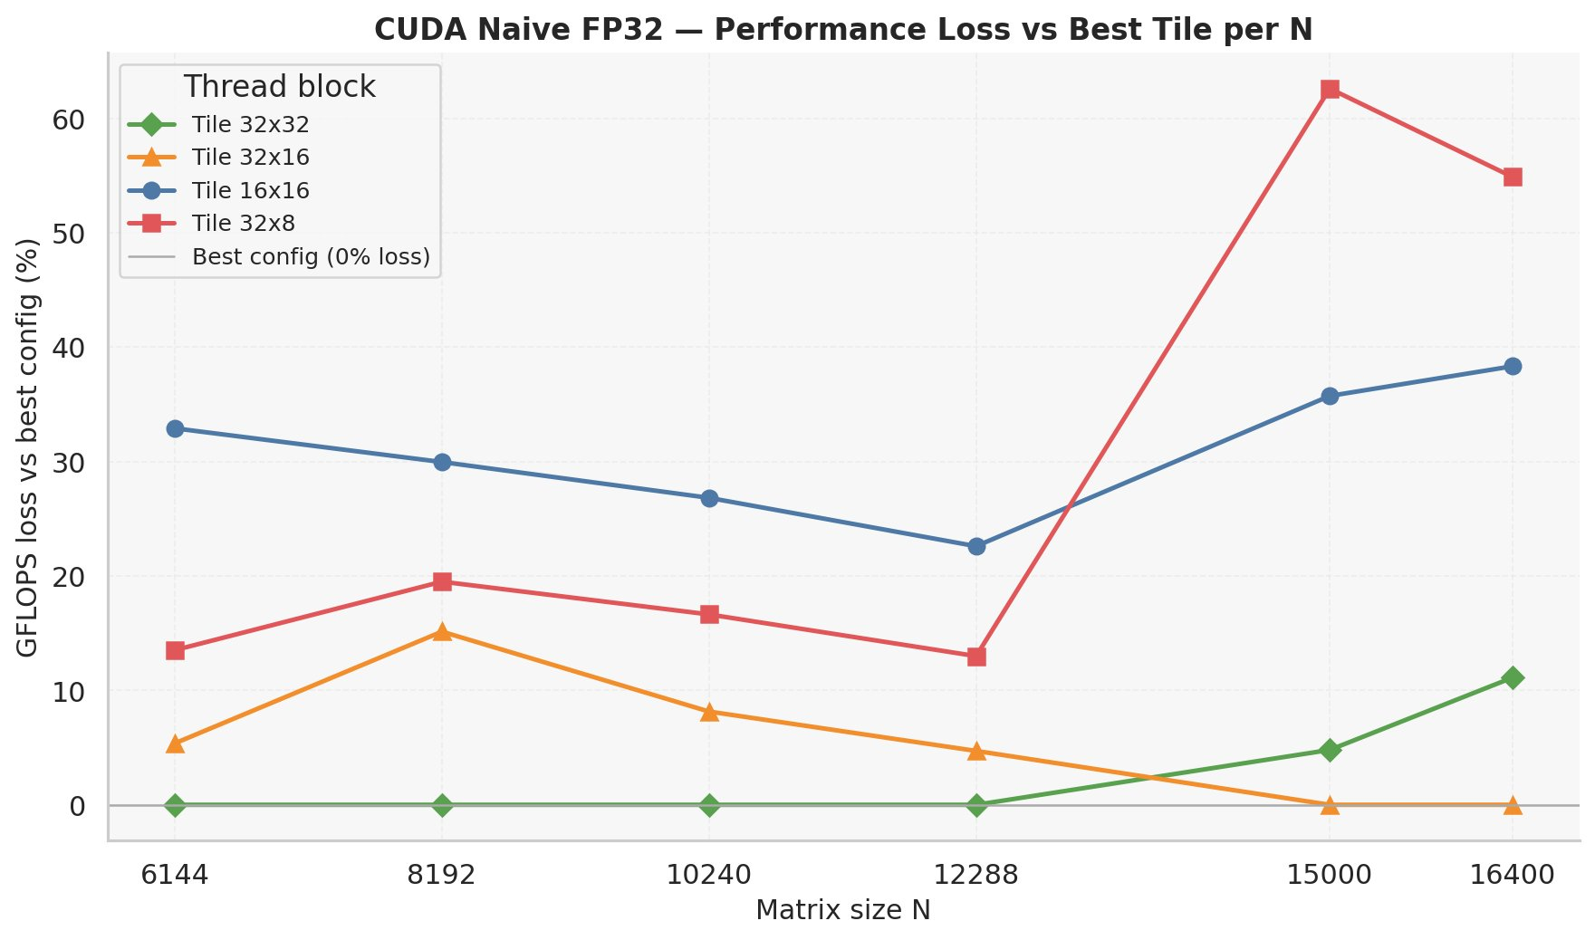
Figure 6. GFLOPS loss (%) vs best tile configuration at each N.

4.7 Speedup over Sequential CPU Baseline
Speedup is computed as T_seq / T_CUDA where T_seq is the best sequential time from the BASE study (icx -O3 -xHost, FP64). For N=15,000 and N=16,400, sequential baselines were estimated by cubic scaling from N=12,288 (marked †).
Speedup peaks at N=8,192 with 30.3×. The high speedup at this size is partly explained by the sequential baseline being unusually slow at N=8,192 (51.9 s) due to cache aliasing at that power-of-two size — documented in the sequential study. The CUDA kernel is unaffected by this aliasing. At N=10,240 speedup drops to 14.5× as the sequential baseline recovers. At N=15,000–16,400, speedups of 18–19× (estimated) represent a more stable regime.
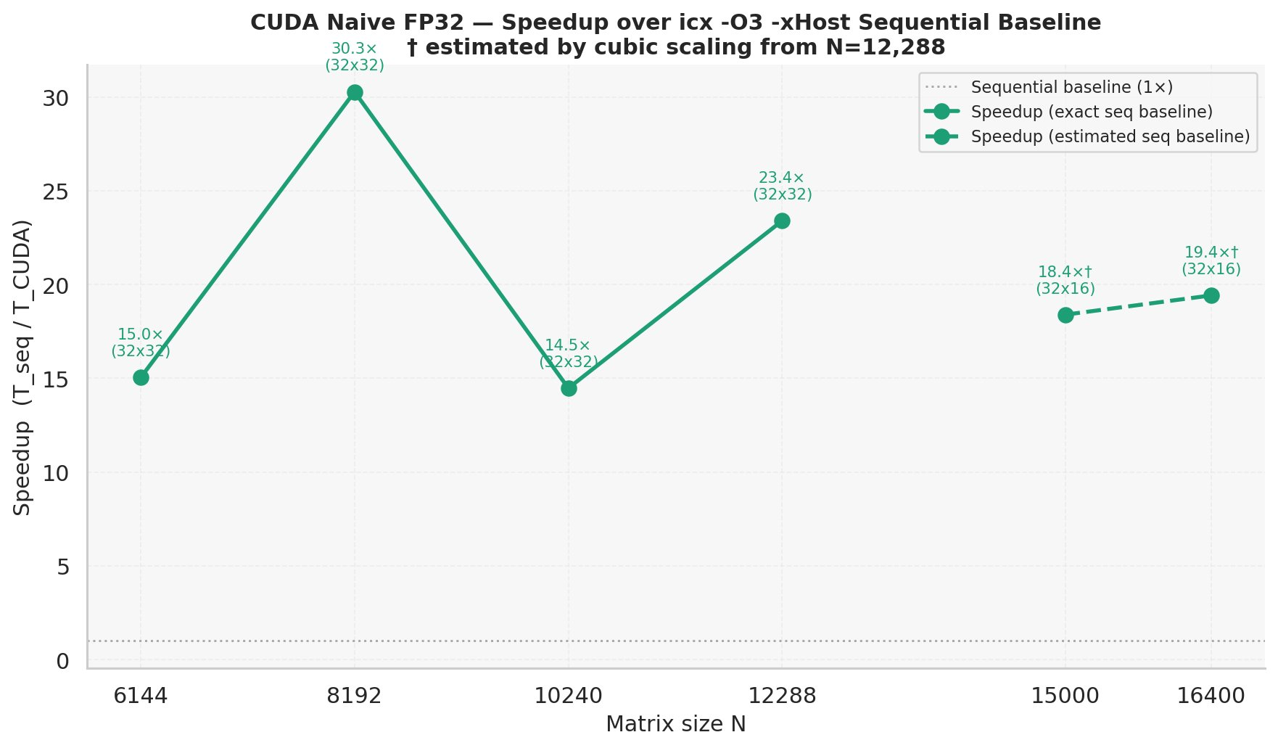
Figure 7. Speedup over icx -O3 -xHost sequential baseline (FP64). Dashed line and † denote estimated baselines by cubic scaling from N=12,288.

4.8 All Tile GFLOPS with Annotated Final Values
Figure 8 repeats Figure 3 with annotated end-point values at N=16,400, confirming 32×16 as best tile for large N (441 GFLOPS), followed by 32×32 (392), 16×16 (272), and 32×8 (199).
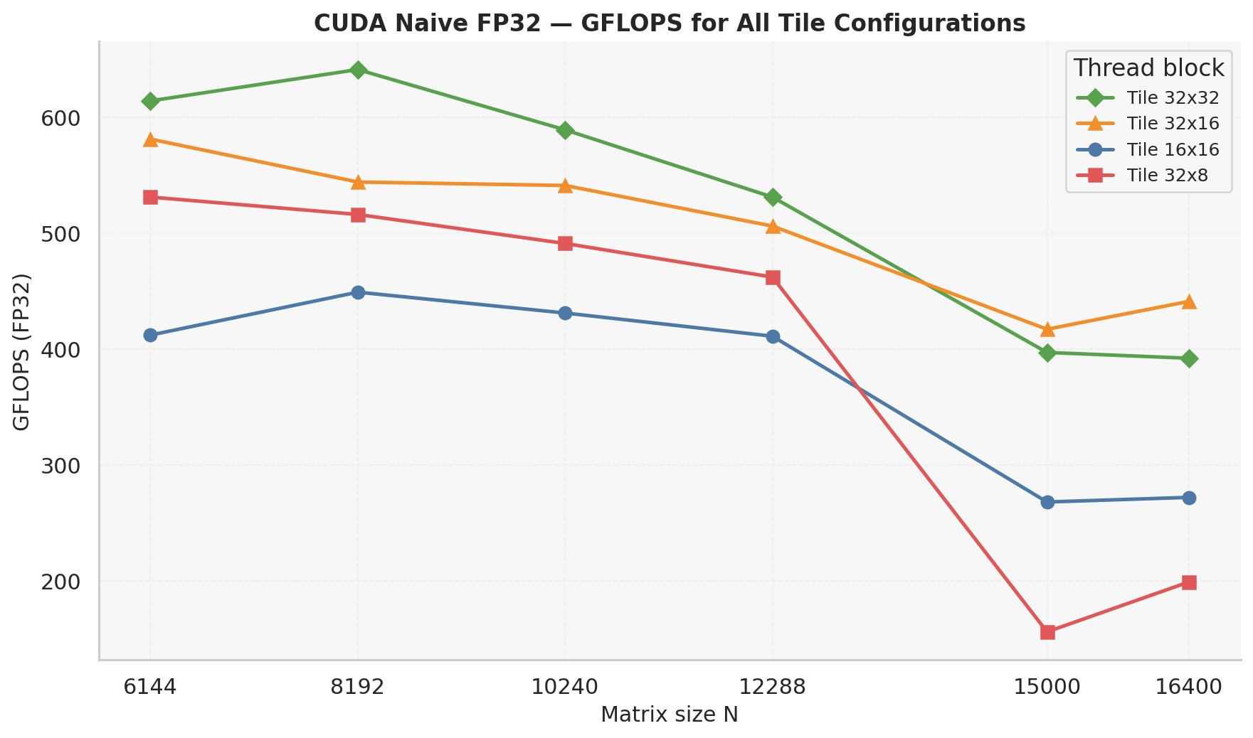
Figure 8. GFLOPS for all tile configurations with annotated final values at N=16,400.

5. Discussion
The naive kernel achieves 400–641 GFLOPS FP32 despite using only global memory. Thousands of independent GPU threads hide memory latency through warp switching. However, this remains far below theoretical GPU FP32 peak throughput, indicating significant memory bandwidth waste from the non-coalesced A access pattern.
The 32×32 superiority for smaller N reflects maximum warp occupancy (1024 threads/block). For larger N, 32×16 overtakes 32×32, possibly because register file pressure at 1024 threads/block reduces occupancy when the working set is large. The 32×8 collapse at N=15,000 is anomalous and may reflect a specific interaction between grid dimensions and the GPU L2 cache partitioning.

6. Limitations
FP32 vs FP64: GPU FP32 throughput is typically 2× FP64 on CUDA hardware. The observed speedup reflects both architectural and precision differences. A direct architectural comparison requires a CUDA FP64 kernel.
No shared memory: The kernel does not exploit shared memory tiling. A tiled version will be compared against these results in future work.
Single run: Each (N, tile) combination was measured once. Results may vary slightly due to thermal throttling or GPU scheduling.
Estimated baselines: Sequential baselines for N=15,000 and N=16,400 were estimated by cubic scaling. These carry uncertainty and the corresponding speedups should be interpreted cautiously.

7. Academic Wording
The naive global-memory FP32 SGEMM kernel achieves a peak throughput of 641 GFLOPS at N=8,192 using a 32×32 thread block configuration. Throughput decreases for larger problem sizes, settling at approximately 418–441 GFLOPS for N ≥ 15,000, consistent with increased memory pressure as the working set exceeds the GPU L2 cache capacity. The 32×8 configuration exhibits an anomalous performance collapse at N=15,000, with throughput falling to 156 GFLOPS, suggesting a cache or occupancy interaction specific to that problem-size and tile combination. Relative to the best sequential CPU baseline (icx -O3 -xHost, double-precision), the GPU kernel achieves speedups between 14.5× and 30.3× across the tested problem sizes. The variability in observed speedup is partly attributed to cache aliasing effects in the sequential baseline at power-of-two matrix sizes, and partly to the precision difference between the FP32 GPU kernel and the FP64 CPU baseline. These factors must be acknowledged when interpreting the reported speedup figures.

8. Conclusion
This study evaluated four thread block configurations for a naive global-memory FP32 CUDA GEMM kernel across six matrix sizes.
Best tile configuration: 32×32 achieves the highest throughput for N ≤ 12,288 (peak 641 GFLOPS at N=8,192). For N ≥ 15,000, 32×16 becomes superior (441 GFLOPS at N=16,400). The 16×16 tile consistently underperforms across all sizes. The 32×8 tile collapses at N=15,000 and should be avoided for large problem sizes.
Speedup over sequential CPU: The kernel achieves 14.5× to 30.3× over the best sequential baseline (icx -O3 -xHost, FP64). The peak at N=8,192 is partly inflated by cache aliasing in the CPU baseline at that power-of-two size. A more representative speedup range for large N is approximately 18–23×.
Next steps: A tiled shared-memory kernel should be implemented to eliminate the non-coalesced global memory accesses to A, which is the primary performance bottleneck of this naive implementation.

